Sandy Lane Nursery and Forest School

“Nurturing curiosity and inspiring imagination”



***2022-23***

Low Level Concerns Policy

**DOCUMENT STATUS**

|  |  |  |  |
| --- | --- | --- | --- |
| **Produced By** | **Version** | **Date** | **Action** |
| Sandy Lane Nursery and Forest School | 1 | 07.11.22 | Approved by Teaching and Learning Committee |
| 2 | 24.9.24 | Pending approval by FGB Dec 24 |

Amendments

V2 – updated name of SG governor and Chair of Governors, update of KCSIE 2024 link, low level concerns amended in line with KCSIE 2024,

Sandy Lane Nursery and Forest School

**SCHOOL DETAILS**

Headteacher: Marcia Atherton

Designated Safeguarding Lead (DSL): Kirsten Matthews

Deputy Designated Safeguarding Lead: Marcia Atherton

Second Designated Safeguarding Lead; Nicola Carney

Designated Governor for Safeguarding: Kayleigh Rees

Chair of Governors: Lucinda Duffy

**CONTENTS**

|  |  | **Page** |
| --- | --- | --- |
| **1** | Introduction | **3** |
| **2** | Summary | **3** |
| **3** | Keeping Children Safe in Education September 2021 | **3** |
| **4** | Clarity around Allegation vs Low-Level Concern vs Appropriate Conduct | **4** |
| **5** | Storing and use of Low-Level Concerns and follow-up information | **4** |
| **6** | Process to follow when a Low-Level Concern is raised | **6** |
| **7** | Low Level Concern Form | **7** |

**1. Introduction**

At Sandy Lane Nursery and Forest School, we aim to create an open and transparent culture where all concerns about all adults involved with our school are dealt with promptly and appropriately. We aim to identify any concerning, problematic or inappropriate behaviour early, minimise the risk of abuse and ensure that adults working in or on behalf of our school are clear about professional boundaries and act within these boundaries in accordance with our school ethos.

This policy should be read alongside our Safeguarding and Child Protection Policy, Staff Code of Conduct Policy and Volunteer Policy.

**2. Summary**

It may be possible that a member of staff acts in a way that does not cause risk to children but is, however, inappropriate. A member of staff who has a concern about another member of staff, volunteer or contractor should inform the headteacher about their concern using a *Low-Level Record of Concern Form*. This form should also be completed by any staff member who feels, on reflection, that their actions could have been viewed as a risk to children in their care or that their behaviour has fallen below the standard set out in the Staff Code of Conduct. If the headteacher is absent, completed forms should be handed to the deputy headteacher. In the absence of both these staff members, forms should be handed to the second designated safeguarding lead (Nicola Carney).

## 3. Keeping Children Safe in Education September 2024

The following is taken from [Keeping Children Safe in Education September 2024](https://assets.publishing.service.gov.uk/media/66d7301b9084b18b95709f75/Keeping_children_safe_in_education_2024.pdf)

and identifies what may be considered behaviour relating to low level concern.

***What is a low level concern (LLC)?***

*433. The term ‘low-level’ concern does not mean that it is insignificant. A low-level concern is any concern – no matter how small, and even if no more than causing a sense of unease or a ‘nagging doubt’ - that an adult working in or on behalf of the school or college may have acted in a way that:*

*• is inconsistent with the staff code of conduct, including inappropriate conduct outside of work, and*

*• does not meet the harm threshold or is otherwise not serious enough to consider a referral to the LADO.*

.

***Examples of such behaviour could include, but are not limited to:***

* *being over friendly with children;*
* *having favourites;*
* *taking photographs of children on their mobile phone contrary to school policy;*
* *engaging with a child on a one-to-one basis in a secluded area or behind a closed door; or*
* *humiliating children*

*434. Such behaviour can exist on a wide spectrum, from the inadvertent or*

*thoughtless, or behaviour that may look to be inappropriate, but might not be in*

*specific circumstances, through to that which is ultimately intended to enable*

*abuse.*

*435. Low-level concerns may arise in several ways and from a number of sources. For example: suspicion; complaint; or disclosure made by a child, parent 108 or other adult within or outside of the organisation; or as a result of vetting checks undertaken.*

*436. It is crucial that all low-level concerns are shared responsibly with the right person and recorded and dealt with appropriately. Ensuring they are dealt with effectively should also protect those working in or on behalf of schools and colleges from becoming the subject of potential false low-level concerns or misunderstandings..*

**4. Clarity around Allegation vs Low-Level Concern vs Appropriate Conduct**

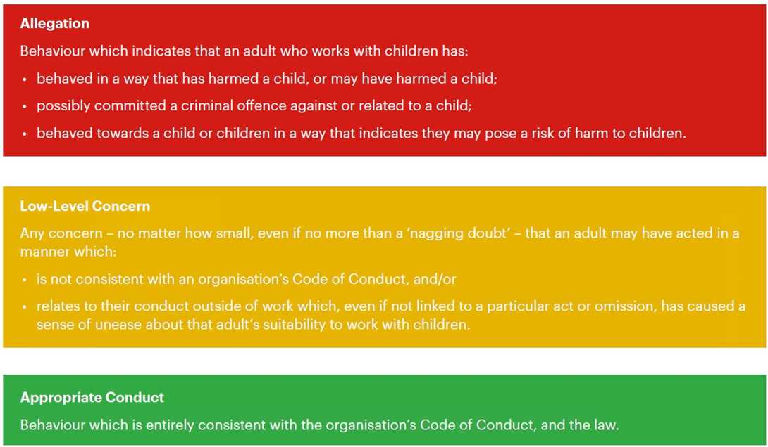

## 5. Storing and use of Low-Level Concerns and follow-up information

Low Level Concern forms and follow-up information will be stored securely within the school’s safeguarding systems and will only be accessed by the senior leadership team. This will be stored in accordance with the school’s GDPR and data protection policies.

The staff member(s) reporting the concern must keep the information confidential and not share the concern with others apart from the headteacher or those aware in the senior leadership team.

**Low-Level Concerns will not be referred to in references unless they have been formalised into more significant concerns resulting in disciplinary or misconduct procedures.**

Whenever a staff member leaves Sandy Lane Nursery and Forest School, any record of low-level concerns which have been stored about them will be reviewed and a decision will be made in relation to whether this information should be retained.

Consideration will be given to:

1. whether some or all of the information contained within any record may have any reasonably likely value in terms of any potential historic employment or abuse claim so as to justify keeping it, in line with normal safeguarding records practice; or
2. on balance, any record is not considered to have any reasonably likely value, still less actionable concern, and ought to be deleted accordingly

**6. Process to follow when a Low-Level Concern is raised**

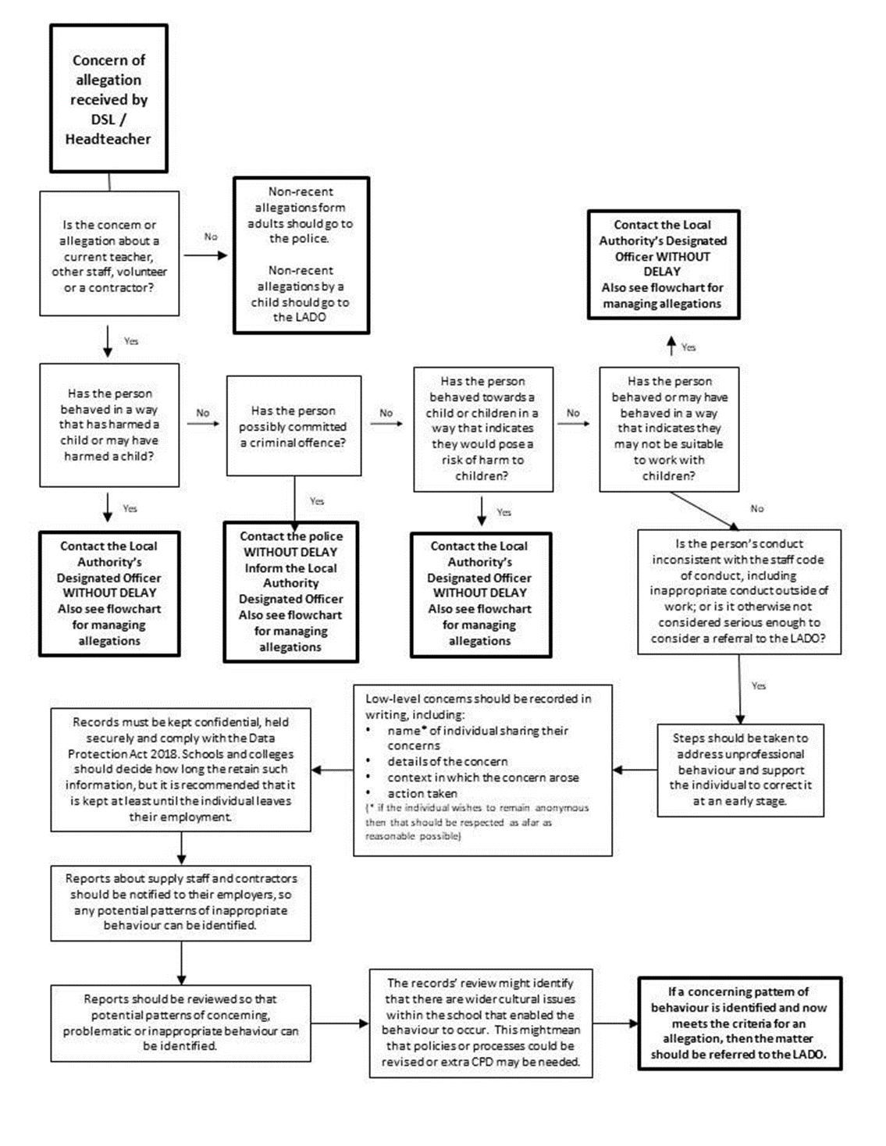

*NB – if the concern is about the headteacher, then the chair of governors (Lucinda Duffy) should be informed.

**7. Low level Concerns Reporting Form –**

**Sandy Lane Nursery and Forest School**

|  |  |  |
| --- | --- | --- |
| **Your details** | | |
| **Name** |  | |
| **Role** |  | |
| **Date and time of completing this form** |  | |
| **Details of individual whom the concern is about** | | |
| **Name** |  | |
| **Role** |  | |
| **Relationship to the individual reporting** eg manager, colleague |  | |
| **Details of concern** | | |
| **Please include as much detail as possible. Think about the following:**   * What behaviour and/or incident are you reporting? * What exactly happened? * Why does the behaviour and/or incident worry you? * Why do you believe the behaviour and/or incident is not consistent with our Staff Code of Conduct? | | |
| **Details of any children or young people involved** | | |
| **Name(s)** |  | |
| **Next Steps** | | |
| **Are you willing to meet with the headteacher and DSL to discuss your concern?** Please circle as appropriate | **Yes** | **No**  *Continued overleaf* |
| **Please state any other information that you feel is relevant to the**  **processing of this concern** |  | |
| **Signature** |  | |
| **For use by HT/safeguarding team upon receipt of the concern** | | |
| **Date and time concern received** |  | |
| **Signature** |  | |
| **Role** |  | |
| **Actions to be taken and follow-up** |  | |